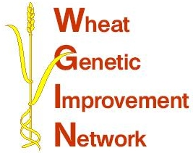

WGIN Management Group Meeting
26th February 2010, Syngenta, Whittlesford

AGENDA

10:00 Arrival and Coffee

10:30 Welcome – John Snape

SELECTED SUBCONTRACTOR PROJECTS:

10:35 Introduction – Elke Anzinger

10:40 Non-destructive screening of WGIN Paragon mutants for grain NUE traits - Richard Weightman

11:00 Exploring the use of Δ¹⁸0 and total mineral ash content in wheat as a new tool for phenotyping wheat with respect to water inputs - John Foulkes

RESEARCH UPDATES:

11:20 Objectives 2, 3 and 4 - Tools and Resources - Simon Griffiths

11:45 Objective 9 - Drought tolerance - John Foulkes

12:00 Objective 10 – Take-all disease – Richard Gutteridge

12:15 Objective 11 – Introgression of extreme Septoria resistance from
T. monococcum into hexaploid wheat - Kim Hammond-Kosack

-----------------------------------------------------------------

12:25 Wheat workshop in Novi Sad, Serbia

12:35 WGIN at Cereals 2010

12:45 AoB

12:55 Lunch
13:55 Core management group afternoon meeting (update on milestones)
15:00 Finish

