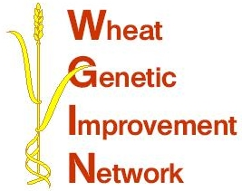

WGIN Management Group Meeting
25th June 2009, NIAB

AGENDA

10:00 Coffee

10:30 Take All / Eyespot results – Kim Hammond-Kosack

11:00 Overview of new website – Elke Anzinger

11:20 Outcome of survey from last meeting

11:40 Update on milestones at JIC – Simon Griffiths

12:00 Crop vernalisation and Avalon x Cadenza workshops – Simon Griffiths

12:05 Subcontractor projects – Peter Shewry

12:35 Topics for stakeholder meeting

12:45 AoB

13:00 Lunch

13:45 Field visit

15.15 Detailed discussion of the WGIN objectives and progress to date.

16.30 Tea and finish

