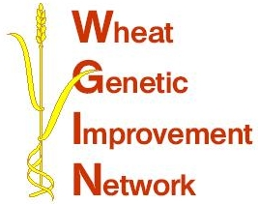

WGIN Management Group Meeting
20th October 2009, University of Nottingham

AGENDA

10:00 Arrival and Coffee

-------------------------------------------------------------------------------------
RESEARCH UPDATES:

10:30 Objectives 2, 3 and 4 - Tools and Resources: Simon Griffiths

10:50 Objective 7 - Insect Resistance: Lesley Smart

11:10 Objective 8 - NUE and NUE linked QTLs : Malcolm Hawkesford

11:30 Objective 9 - Drought tolerance: John Foulkes

11:50 Objective 10 – Take-all disease and objective 11 – Introgression
of extreme Septoria resistance from T. monococcum into hexaploid wheat:
Kim Hammond-Kosack
-------------------------------------------------------------------------------------

12:15 Subcontractor projects: Elke Anzinger

12:30 A community resource for wheat functional genomics – cross searching
databases: Paul Verrier

12:50 AoB

13:00 Lunch
14:00 Afternoon meeting (update on milestones)
15:30 Finish

Location: University of Nottingham, Seminar Room 7 of the SB lecture block at Sutton Bonington

