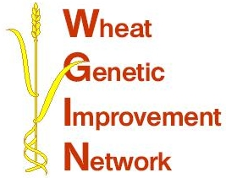

WGIN Management Group Meeting
20th July 2011, Rothamsted Research
AGENDA

10:00 Arrival and Coffee

10:20 Welcome – Peter Shewry
Introduction of the new project assistant – Suzanne Thrussell
RESEARCH UPDATES:

10:35 Objectives 2, 3 and 4 - Tools and Resources - Simon Griffiths

10:55 Objective 8 – NUE and QTLs linked to NUE – Malcolm Hawkesford

11:15 Objective 9 – Drought tolerance - John Foulkes

11:35 Objective 10 – Take-all disease
– Kim Hammond-Kosack and Richard Gutteridge

11:55 Feedback on cereals 2011 – WGIN demonstration plots

Discussion on the 22nd Nov 2011 Stakeholder meeting – Topics, speakers, panellists for the discussion on ‘Successful 2nd and 3rd wheats’

-----------------------------------------------------------------

12:30 Lunch

13:00 Field visit – WGIN trials – Malcolm and Richard to decide on tour route

15.15 Afternoon – tea – coffee

15.30 Milestones – core management group

16.15 Finish

Location: Rothamsted Research

