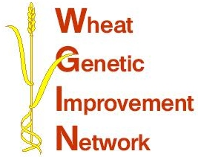

WGIN Management Group Meeting
16 February 2011, KWS, Royston
AGENDA

10:00 Arrival and Coffee

10:30 Welcome – Peter Shewry
RESEARCH UPDATES:

10:35 Objectives 2, 3 and 4 - Tools and Resources - Simon Griffiths

10:55 Final report on objective 7 – Aphid susceptibility – Lesley Smart or Ruth Gordon-Weeks

11:15 Objective 8 – NUE and QTLs linked to NUE – Malcolm Hawkesford

11:35 Objective 9 – Drought tolerance - John Foulkes

11:55 Objective 10 – Take-all disease and Objective 11 – Septoria resistance
– Kim Hammond-Kosack

-----------------------------------------------------------------

12:15 Update on Nottingham Subcontractor project – John Foulkes

12:35 Update on ADAS Subcontractor project – Richard Weightman

12:55 Lunch

13:55 CGIAR Seeds of Discovery proposal – Simon Griffiths

14:15 Discussion – Review of the June 2007 breeder’s priority traits list

14:35 Cereals 2011 JIC and RRes stand

14:45 AoB (report back from phenotyping workshop)

14:55 Milestones – core management group

15:30 Finish

Location: KWS, 56 Church Street, Thriplow, Royston, Herts, SG8 7RE, Tel: 01763 207300

