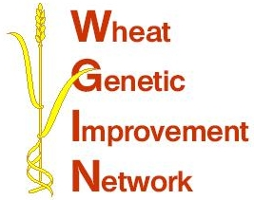

WGIN Management Group Meeting
4th November 2010, Rothamsted Research
AGENDA

10:00 Arrival and Coffee

10:30 Welcome – Peter Shewry
RESEARCH UPDATES:

10:35 Objectives 2, 3 and 4 - Tools and Resources - Simon Griffiths

10:55 Objective 8 – NUE and QTLs linked to NUE – Malcolm Hawkesford

11:05 Objective 9 - Drought tolerance - John Foulkes

11:15 Objective 10 – Take-all disease – Kim Hammond-Kosack

11:30 The extended Avalon x Cadenza DH population at RRes –
Kim Hammond-Kosack

-----------------------------------------------------------------

11:45 Update on the field phenotyping/robotics meeting – Martin Parry

11:55 Discussion: WGIN response to the establishment of the
UK Plant Sciences Federation

12:20 Selecting questions for the panel discussion on UK wheat field yields
lagging behind breeders projections

12:35 AoB

12:50 Lunch

13:50 Milestones – core management group

14:20 Finish

Location: Rothamsted Research Conference Centre, Elliot Suite

