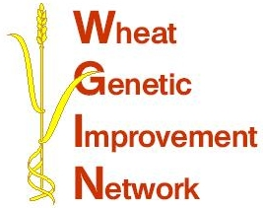

WGIN Management Group Meeting
12th March 2009, RRes

AGENDA

10:00 Coffee

10:30 WGIN 2 – Kim Hammond-Kosack
- Content of the new proposal
- New management meeting arrangements
- Forthcoming changes to the WGIN website

11:15 Sub-contractors projects – Peter Shewry
Discussion of possible topics and tendering arrangements

11:30 WGIN - social and economic impact
Discussion in the context of defra’s main drivers for research

11:50 Hurdles to the implementation of public good science:
Discussion on how the breeders can come on board

12:10 The new BBSRC wheat sequencing proposal – Keith Edwards or another

12:30 EU Healthgrain - G x E associations – Peter Shewry

12:45 AoB

13:00 Lunch

