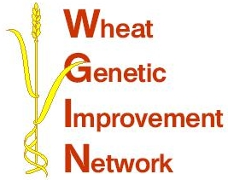

WGIN Management Group Meeting
12 August, JIC, Norwich

AGENDA

10:30 Arrival and Coffee

11:00 Objectives 2, 3 and 4 - Tools and Resources: Simon Griffiths, JIC

11:20 Eyespot resistance in the Watkins Collection - Chris Burt, JIC

11:40 Update on the Crop Improvement Club - Jayne Brookman, BBSRC

12:00 Report from the Serbia wheat workshop – Peter Shewry, RRes

12:20 Community efforts on phenotyping – Ian Mackey, NIAB

12:40 AoB

13:00 Lunch and finish

Meeting location: Bateson Boardroom, John Innes Centre, Norwich

